June 1, 2024
MAILING LABEL
Property ID:
Commercial Property Owner
Street Address
City, State Zip
Please enclose a copy of this page with your submission.

Re: Local Law No. 3 – 2009 – Requiring the Annual Filing of Income and Expense Statements for Income Producing Real Property

Dear Commercial Property Owner:

The Town of Ramapo recently passed Local Law No. 3 – 2009, “Requiring the Annual Filing of Income and Expense Statements for Income Producing Real Property.” Attached is a copy of the law which you should read through carefully. We have also included the required forms for your convenience.

Please note that these forms are due no later than July 1, 2024. The law states that in the event that the statement(s) are not filed on time, or at all, “…the Board of Assessment Review shall deny any complaint filed in relation to the assessment of such owner’s property for said year.” Other remedies may be taken and are outlined in the attached law.

Please fill out the attached forms, and submit to the Office of the Assessor on or before, but not later than July 1st.

Very truly yours,
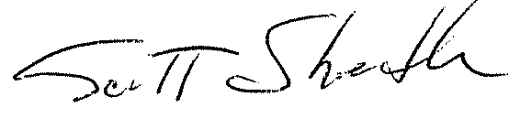

Scott J. Shedler, IAO
Assessor

